1 run......

Downloading: 100%

411/411 [00:00<00:00, 14.8kB/s]

Downloading: 100%

263M/263M [00:06<00:00, 43.9MB/s]

training 1 epoch...

71.07428216934204 seconds used......

1 training finished! average train loss: 0.994279452023052

evaluating...

Confusion matrix, without normalization

[[105 19 0]

[ 58 103 3]

[733 60 72]]

Normalized confusion matrix

[[0.84677419 0.15322581 0. ]

[0.35365854 0.62804878 0.01829268]

[0.84739884 0.06936416 0.08323699]]

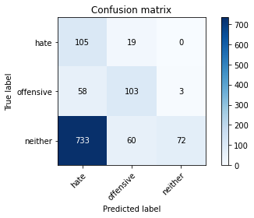

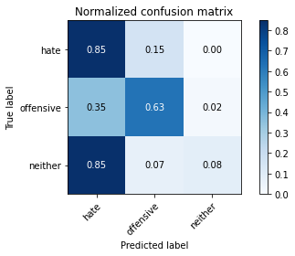

precision recall f1-score support

hate 0.12 0.85 0.21 124

offensive 0.57 0.63 0.60 164

neither 0.96 0.08 0.15 865

accuracy 0.24 1153

macro avg 0.55 0.52 0.32 1153

weighted avg 0.81 0.24 0.22 1153

average eval_loss: 1.073066344548916, accuracy: 0.24284475281873374

training 2 epoch...

70.22050142288208 seconds used......

2 training finished! average train loss: 0.8529830245035035

evaluating...

Confusion matrix, without normalization

[[ 71 40 13]

[ 28 125 11]

[364 129 372]]

Normalized confusion matrix

[[0.57258065 0.32258065 0.10483871]

[0.17073171 0.76219512 0.06707317]

[0.42080925 0.14913295 0.4300578 ]]

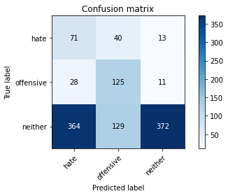

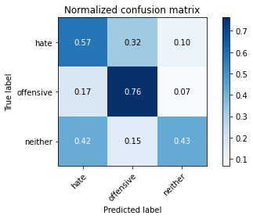

precision recall f1-score support

hate 0.15 0.57 0.24 124

offensive 0.43 0.76 0.55 164

neither 0.94 0.43 0.59 865

accuracy 0.49 1153

macro avg 0.51 0.59 0.46 1153

weighted avg 0.78 0.49 0.55 1153

average eval_loss: 0.919347253339044, accuracy: 0.49262792714657416

training 3 epoch...

70.21208238601685 seconds used......

3 training finished! average train loss: 0.6972240846426714

evaluating...

Confusion matrix, without normalization

[[ 98 16 10]

[ 49 104 11]

[521 50 294]]

Normalized confusion matrix

[[0.79032258 0.12903226 0.08064516]

[0.29878049 0.63414634 0.06707317]

[0.60231214 0.05780347 0.33988439]]

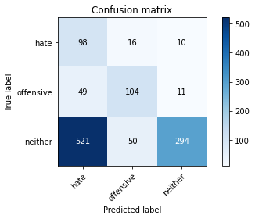

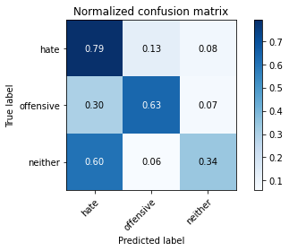

precision recall f1-score support

hate 0.15 0.79 0.25 124

offensive 0.61 0.63 0.62 164

neither 0.93 0.34 0.50 865

accuracy 0.43 1153

macro avg 0.56 0.59 0.46 1153

weighted avg 0.80 0.43 0.49 1153

average eval_loss: 1.1192403076023891, accuracy: 0.43018213356461404

training 4 epoch...

70.1287362575531 seconds used......

4 training finished! average train loss: 0.4464678561226243

evaluating...

Confusion matrix, without normalization

[[ 77 30 17]

[ 30 114 20]

[365 63 437]]

Normalized confusion matrix

[[0.62096774 0.24193548 0.13709677]

[0.18292683 0.69512195 0.12195122]

[0.42196532 0.07283237 0.50520231]]

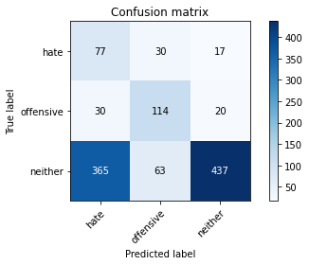

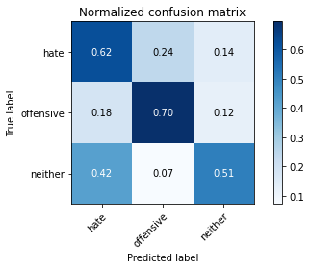

precision recall f1-score support

hate 0.16 0.62 0.26 124

offensive 0.55 0.70 0.61 164

neither 0.92 0.51 0.65 865

accuracy 0.54 1153

macro avg 0.55 0.61 0.51 1153

weighted avg 0.79 0.54 0.60 1153

average eval_loss: 1.1239584663818623, accuracy: 0.5446660884648742

training 5 epoch...

70.25675249099731 seconds used......

5 training finished! average train loss: 0.21363558117965503

evaluating...

Confusion matrix, without normalization

[[ 85 19 20]

[ 34 111 19]

[442 56 367]]

Normalized confusion matrix

[[0.68548387 0.15322581 0.16129032]

[0.20731707 0.67682927 0.11585366]

[0.51098266 0.06473988 0.42427746]]

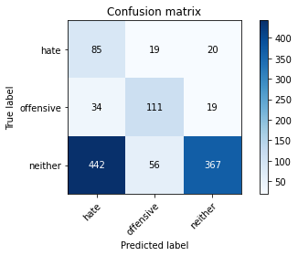

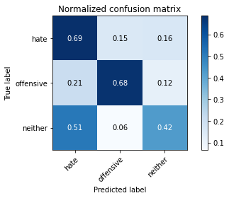

precision recall f1-score support

hate 0.15 0.69 0.25 124

offensive 0.60 0.68 0.63 164

neither 0.90 0.42 0.58 865

accuracy 0.49 1153

macro avg 0.55 0.60 0.49 1153

weighted avg 0.78 0.49 0.55 1153

average eval_loss: 1.6914427568172585, accuracy: 0.48829141370338247

2 run......

training 1 epoch...